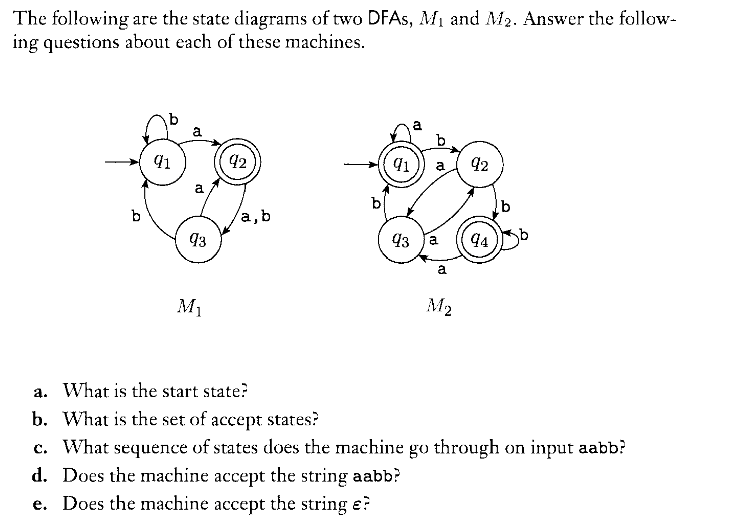

1. Give a formal description of the above two DFAs by specifying the 5-tuple.
2. Construct a Deterministic Finite Automata accepting each of the following:

There can be different answers. The followings are just two examples.

3.1 {$w∈{\left\{a,b\right\}}^{*}:w has abab as a substring$}

3.2 {$w∈{\left\{a,b\right\}}^{*}:w has neither aa nor bb as a substring$}